ASAS-SN Plug-in for VStar
Description: This plugin allows you to open text files in the All-Sky Automated Survey for Supernovae (ASAS-SN) formats.
Currently (on 18 Apr 2023), ASAS-SN data comes in three formats. The first and oldest one is provided by the ASAS-SN Sky Patrol. The second format comes from the ASAS-SN Photometry Database and ASAS-SN Variable Stars Database. Those databases contain pre-computed light curves The newest ASAS-SN service, ASAS-SN Sky Patrol V2.0, provides the data in the third form.

Table of content
ASAS-SN Sky Patrol V1.0 2
ASAS-SN Sky Patrol V2.0 6
Pre-computed ASAS-SN Light Curves 9

ASAS-SN Sky Patrol V1.0
ASAS-SN Sky Patrol data are computed in real-time using aperture photometry for a point on the celestial sphere for which ASAS-SN images exist. Go to the Sky Patrol website
[ https://asas-sn.osu.edu/ ], enter the coordinates of a target and the number of days to go back, then press [Compute]
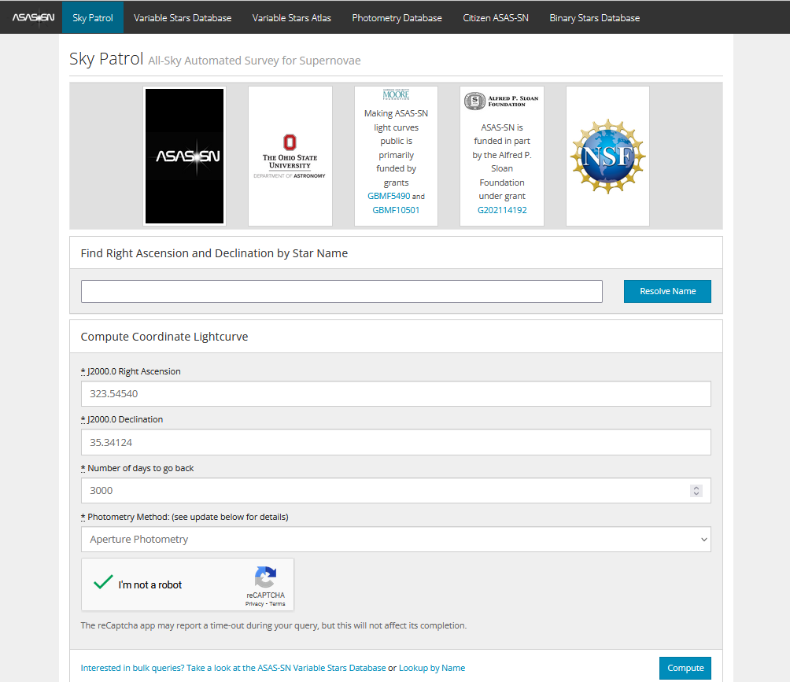

The calculations may take a while. When calculations succeed, you will be redirected to the result page.
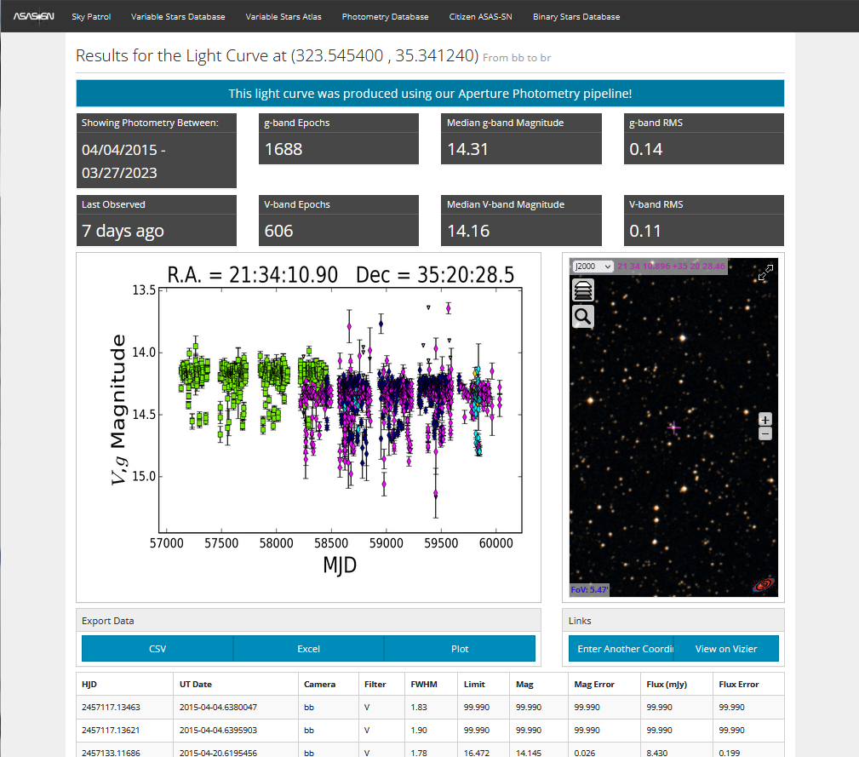

Press the [CSV] button under “Export Data” and save the CSV file to disk. The file contains V and g bands data, as seen from the preview plot.
From VStar, select [New Star from File...] from the [File] menu and then select “ASAS-SN” in the “Source” dropdown list. Go to the location of the saved file and open it.
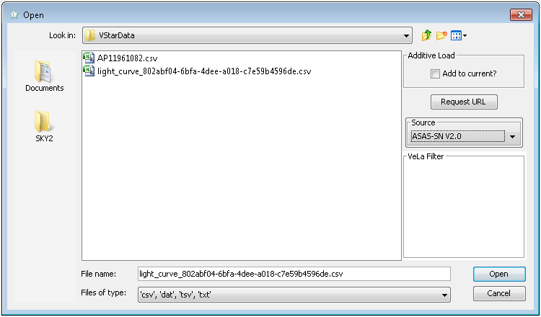

The following dialog will appear:
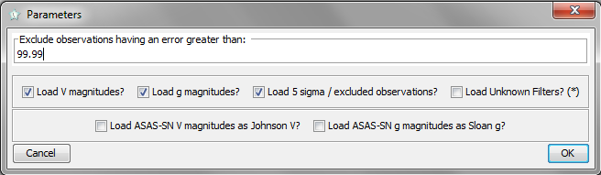

Currently, ASAS-SN light curves can contain data for V and g bands. Some observations in a file can be marked as unreliable (“5 sigma/excluded observations”); they can be excluded by unchecking the corresponding checkbox. A user can limit the maximum allowed uncertainty (“Exclude observations having an error greater than” field).
Select the data you need (let’s assume you have selected data for the V band only) and press OK. VStar will show you a light curve:
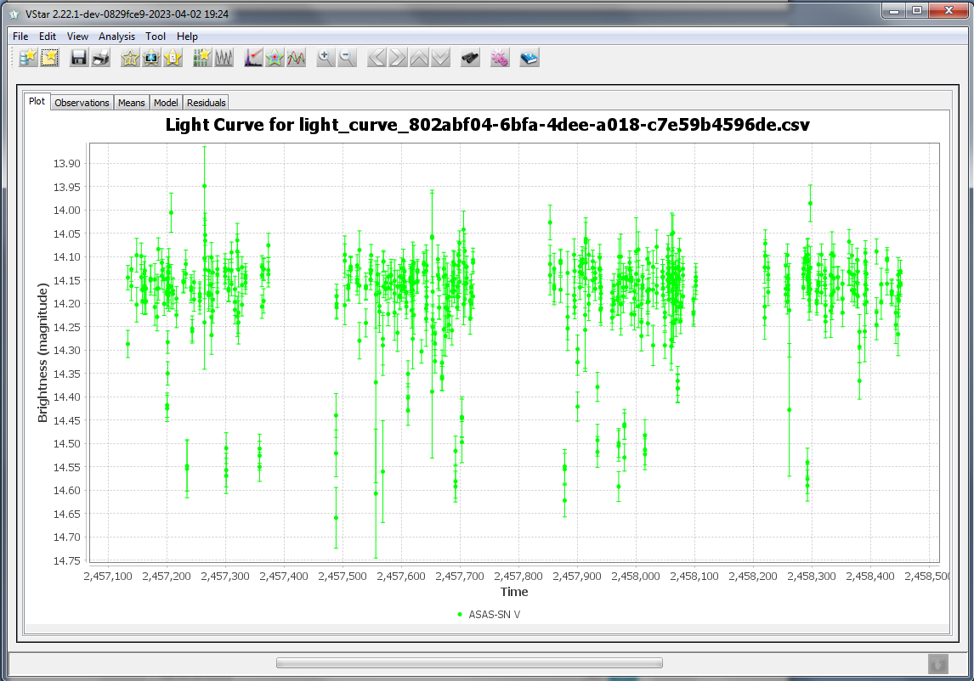

Here is the phase plot for the star (it is an eclipsing binary with a period of 1.095355 days:
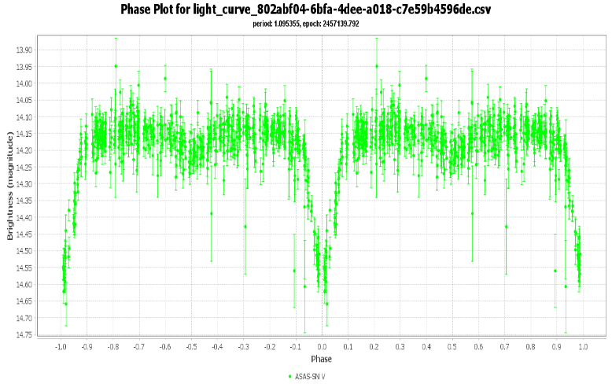

ASAS-SN Sky Patrol V2.0
The new ASAS-SN Sky Patrol V2.0, as it is claimed in [ https://arxiv.org/abs/2304.03791 ], “not only serves pre-computed lightcurves for a select list of ∼111 million targets, but it also continuously updates the lightcurves in real time.”
To find the light curve, go to http://asas-sn.ifa.hawaii.edu/skypatrol/. On the page, enter RA, Dec, and the search radius in the appropriate fields, then click [Search]:
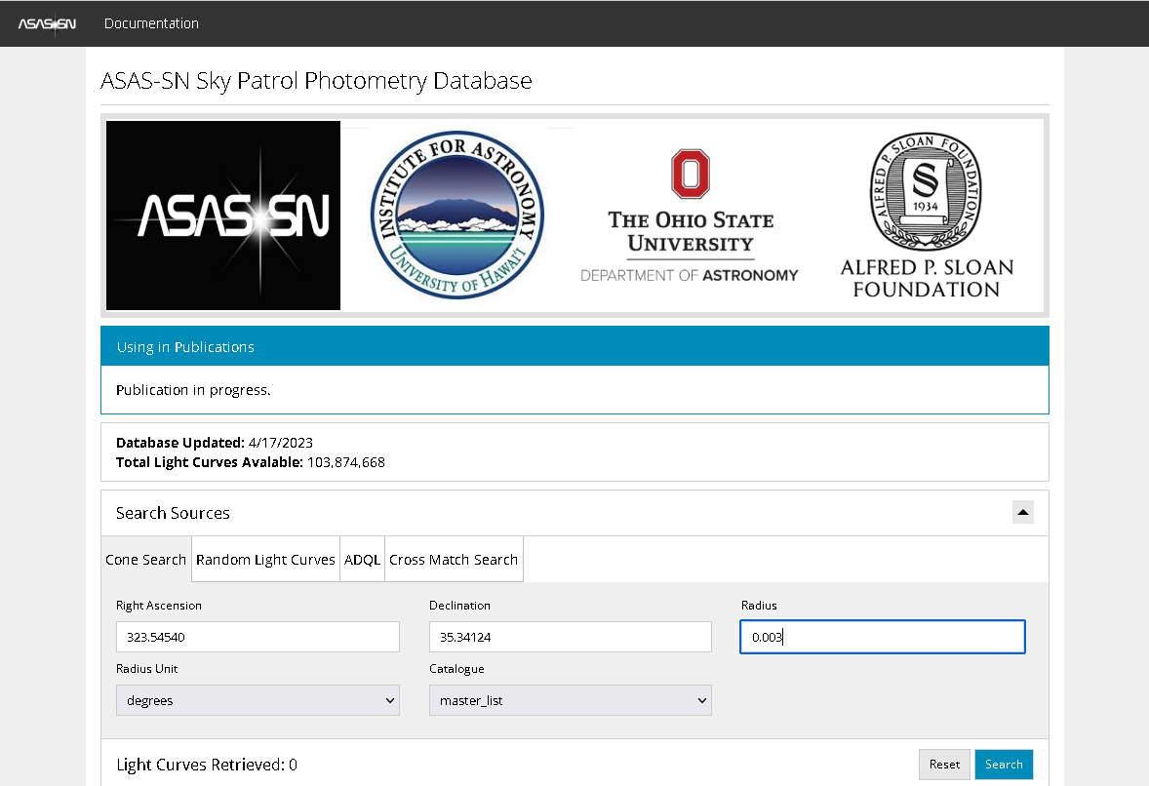

If the search is successful, you will see one or more links to the light curves:
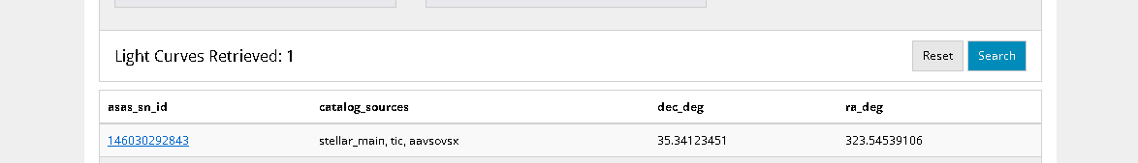

Click on a link, and you will be redirected to the light curve page. Click the [CSV] button to download the data:
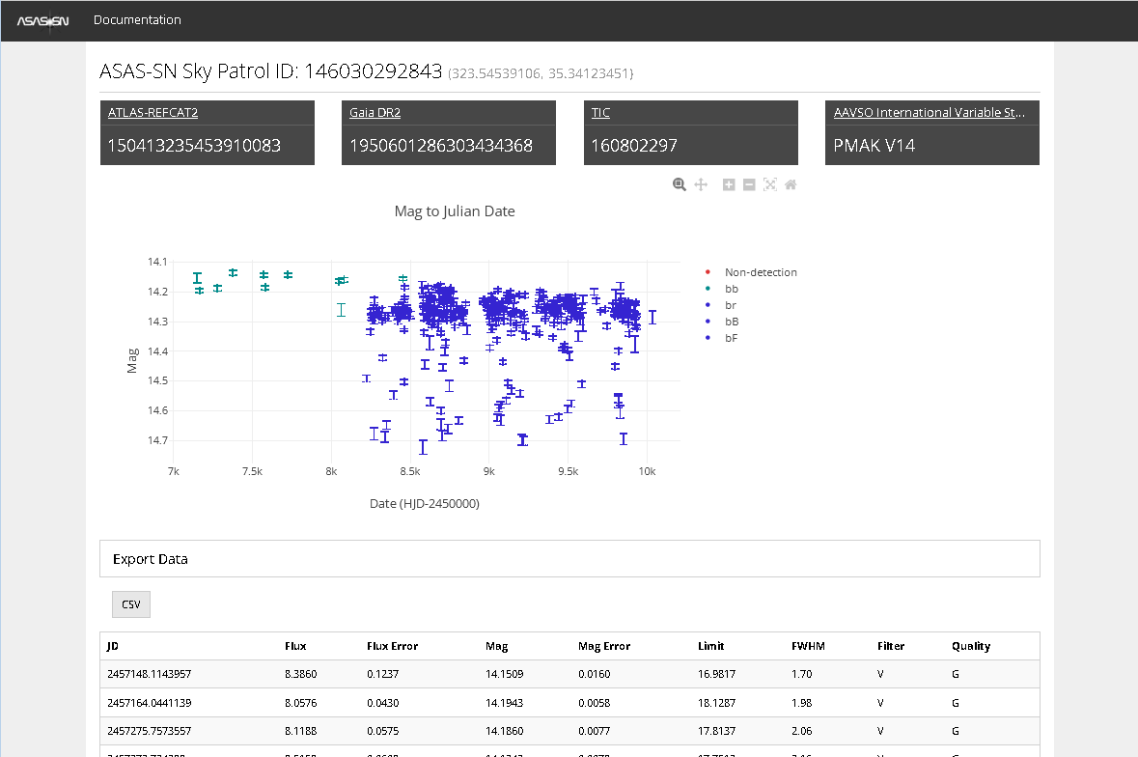

Open the CSV file in the same way as described in the previous chapter (in this example, all three V, g, and 5-sigma checkboxes were checked):
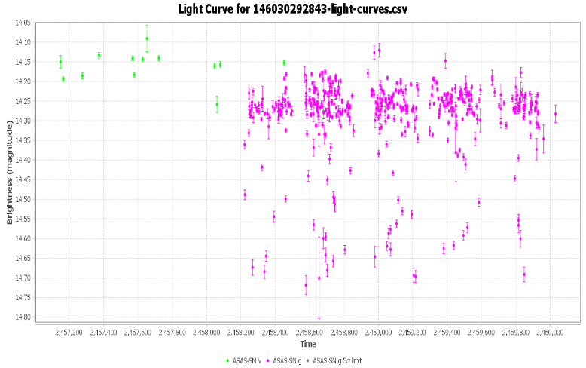

The new format contains the “Quality” column. ASAS-SN advises caution when using data that has not been flagged as “good” [ https://arxiv.org/abs/2304.03791 ] (i.e., contains the “G“ flag in the “Quality” column:
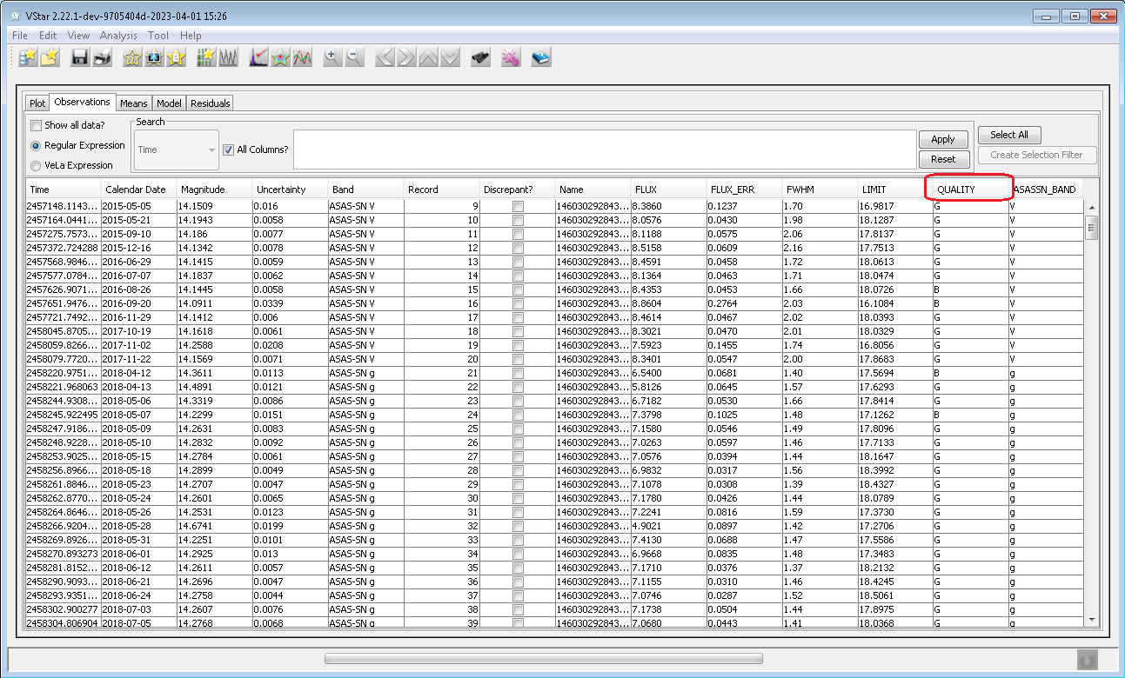

Pre-computed ASAS-SN Light Curves
Other sources for ASAS-SN light curves are ASAS-SN Photometry Database [ https://asas-sn.osu.edu/photometry ] and ASAS-SN Variable Stars Database [ https://asas-sn.osu.edu/variables ]. Those databases contain ready-to-use light curves in a format that differs from one produced by Sky Patrol. The plugin loads files of both formats.
To download a light curve, go to one of the databases and enter the coordinates and the search radius (for both databases) or ASAS-SN variable name (for the Variable Star Database). If precomputed curves exist, they will be listed. Do not load the data via [Download CSV Dataset] button (the format is currently not supported by the plugin). Instead, click on one of the curves’ IDs.
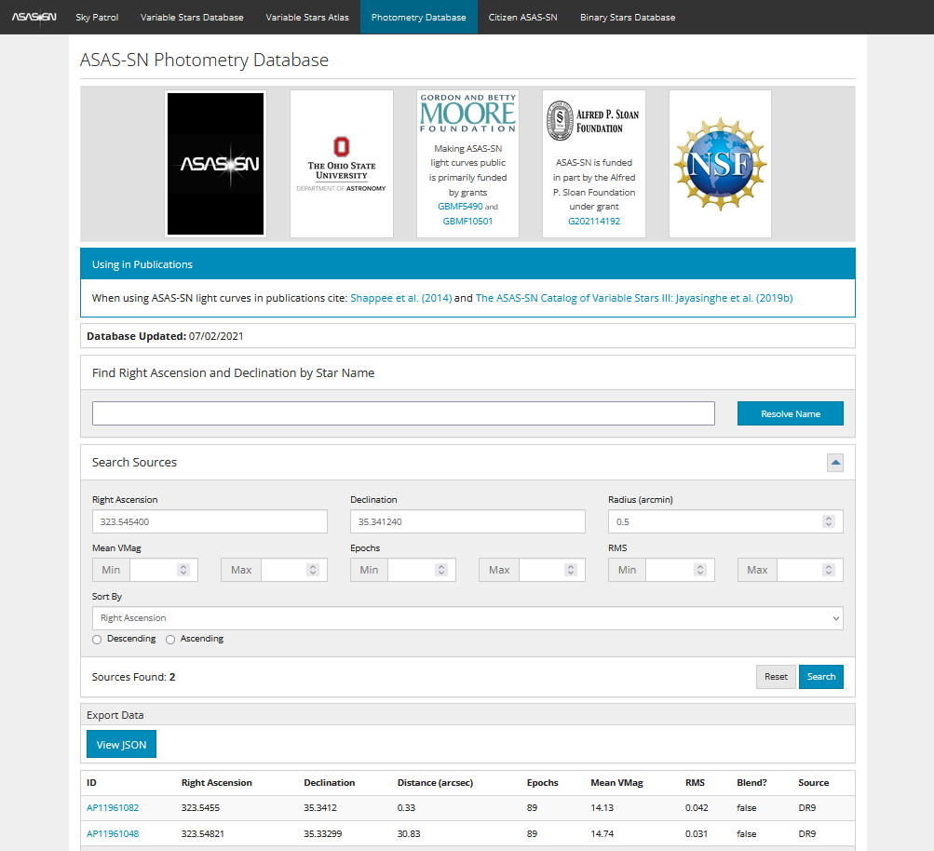

You will see a new window with a preview plot. Click on the [CSV] button under “Export Data” to download a file. This file can be opened by the plugin in the same way as described above.
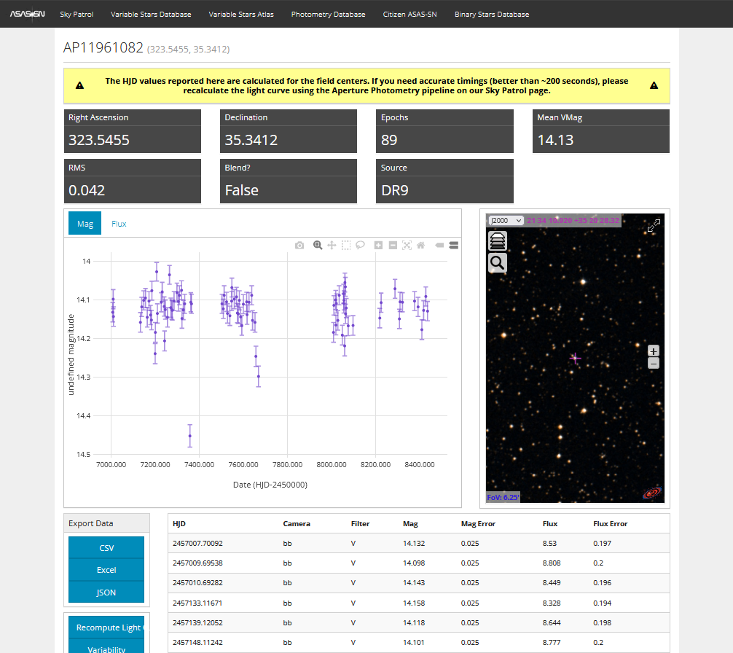

Maksym Pyatnytskyy (PMAK)
Rev D
2023-04-18
Revision History
Rev | Date | Description
D | 2023-04-18 | SkyPatrol V2.0
C | 2023-04-02 | Updated according to the last plugin’s revision
B | 2020-04-26 | Open Dialog image added
A | 2020-04-17 | Initial Release

